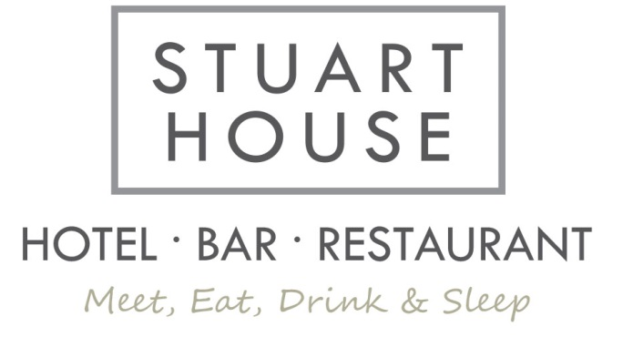
Starters
Soup of the Day £4.50
Breaded Butterfly Prawns with chilli dip and salad £6.50
Chicken Satay with peanut sauce and salad leaves £5.95

Mains
"Toad in the hole" Giant yorkie, Sausages & vegetables (Veggie option available) £12.00
Scampi with chips, or new potatoes, and peas £12.95
Sausage & Mash with onion gravy (Veggie option available) £12.00
Burger, or cheeseburger with Chips and salad (Veggie option available) £13.95
Lasagne with salad (add new potatoes or chips for £1.50) £12.50
Chicken & Mushroom Pie with mash vegetables and gravy £13.50
Mince Beef and Ale Pie with mash potato vegetables and gravy £13.50
Chilli, rice and Garlic bread £12.75

Desserts
Warm Chocolate Fudge Cake with Cream £5.50
Sticky toffee pudding with cream or ice cream £5.50
Lemon Roulade with fresh cream and Coulis £5.50
Mixed Ice Cream £4.00
Please ask about the ingredients in our food if you have any special dietary requirements

